Suman Paudel (33)

Assignment I

# Lab 1:

**Prepare Lab Sheet of MYSQL Statements for following.**

1. Create a database named “Yourname_Roll_COMPANY” e.g.: Atiz_02_Company and then create following tables within the database. Specify proper primary keys and the needed constraints while defining the tables. Use appropriate data types for the attributes.
2. Employee (SSN, Ename, Gender, Bdate, Address, Salary, Ono, Years_of_experience); whereOno is a foreign key referencing to the Office table. Set default value of salary to 0.00. The Ename should not be null. Set SSN to auto increment. The Ename and address should be varchar, Gender should be char(1), Bdate should be date type, Salary should be decimal type with two digits after decimal.Years_of_experience should be integer. Use Check constraint for gender as CHECK (Gender  [IN](http://localhost/phpmyadmin/url.php?url=https://dev.mysql.com/doc/refman/5.5/en/comparison-operators.html#function_in) (‘M’, ‘F’))
3. Office (Onumber, Oname, Country); where Oname should not be NULL. Country should be varchar.
4. Project (Pnumber, Pname, Plocation, Onumber); where Onumber is a foreign key referencing Office table. Create a constraint name fk_pro for the foreign key. Pname should be unique and should not be null. Both Pname and Plocations should be of type varchar(40).
5. Works_on( ESSN, Pno); where ESSN references Employee SSN and Pno references to Pnumber from Project . Set cascade on update and cascade on delete to both
6. Dependents(Did, Dname, Dage, SSN); where SSN is Foreign key referencing the employee. Set NULL on delete and on update to the foreign key. Add constraint age_constraint using CHECK(Dage<16).

Create a database named “Yourname_Roll_COMPANY” e.g.: Atiz_02_Company and then create following tables within the database. Specify proper primary keys and the needed constraints while defining the tables. Use appropriate data types for the attributes.

**SQL Script**:

**DROP** **DATABASE** **IF** **EXISTS suman_33_company**;

**CREATE** **DATABASE** suman_33_company;

\c suman_33_company;

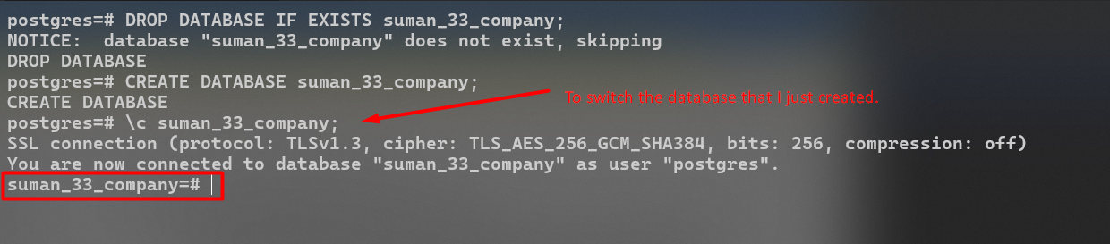**Output:**

**1a.** Employee (SSN, Ename, Gender, Bdate, Address, Salary, Ono, Years_of_experience); where Ono is a foreign key referencing to the Office table. Set default value of salary to 0.00. The Ename should not be null. Set SSN to auto increment. The Ename and address should be varchar, Gender should be char(1), Bdate should be date type, Salary should be decimal type with two digits after decimal.Years_of_experience should be integer. Use Check constraint for gender as CHECK (Gender  [IN](http://localhost/phpmyadmin/url.php?url=https://dev.mysql.com/doc/refman/5.5/en/comparison-operators.html#function_in) (‘M’, ‘F’))

**\*\*Note** Error was thrown when trying to create employee table which has “Ono” column being referenced to Office table which is currently not in the database. So, first I had to create Office table then I created Employee table.**

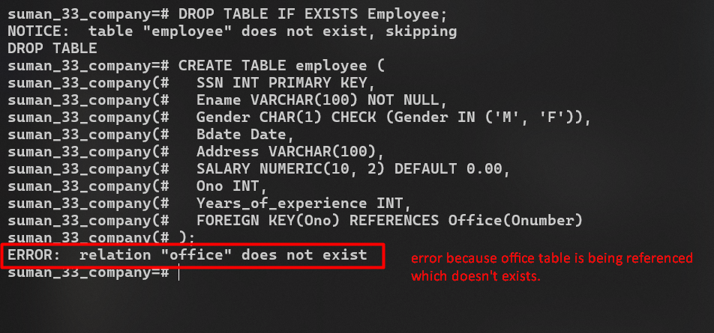**Error:**

**SQL Script:**

**DROP** **TABLE** **IF** **EXISTS** Employee;

**CREATE** **TABLE** employee (

SSN **INT** **PRIMARY** **KEY**,

Ename **VARCHAR**(100) **NOT** **NULL**,

Gender **CHAR**(1) **CHECK** (Gender **IN** (**'M'**, **'F'**)),

Bdate **Date**,

Address **VARCHAR**(100),

SALARY **NUMERIC**(10, 2) **DEFAULT** 0.00,

Ono **INT**,

Years_of_experience **INT**,

**FOREIGN** **KEY**(Ono) **REFERENCES** Office(Onumber)

);

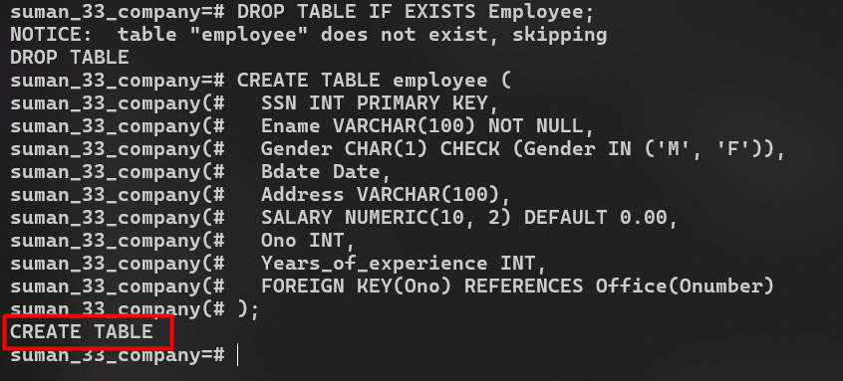**Output:**

**1b.** Office (Onumber, Oname, Country); where Oname should not be NULL. Country should be varchar.

**SQL Script**:

**DROP** **TABLE** **IF** **EXISTS** Office;

**CREATE** **TABLE** Office(

Onumber **INT** **PRIMARY** **KEY**,

Oname **VARCHAR**(100) **NOT** **NULL**,

Country **VARCHAR**(50)

);

**Output:**

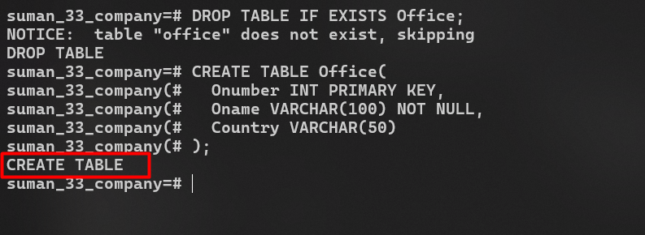

**1c:** Project (Pnumber, Pname, Plocation, Onumber); where Onumber is a foreign key referencing Office table. Create a constraint name fk_pro for the foreign key. Pname should be unique and should not be null. Both Pname and Plocations should be of type varchar(40).

**SQL Script:**

**DROP** **TABLE** **IF** **EXISTS** Project;

**CREATE** **TABLE** Project (

Pnumber **INT** **PRIMARY** **KEY**,

Pname **VARCHAR**(40) **UNIQUE** **NOT** **NULL**,

Plocation **VARCHAR**(40),

Onumber **INT**,

**CONSTRAINT** fk_pro **FOREIGN** **KEY** (Onumber) **REFERENCES** Office(Onumber)

);

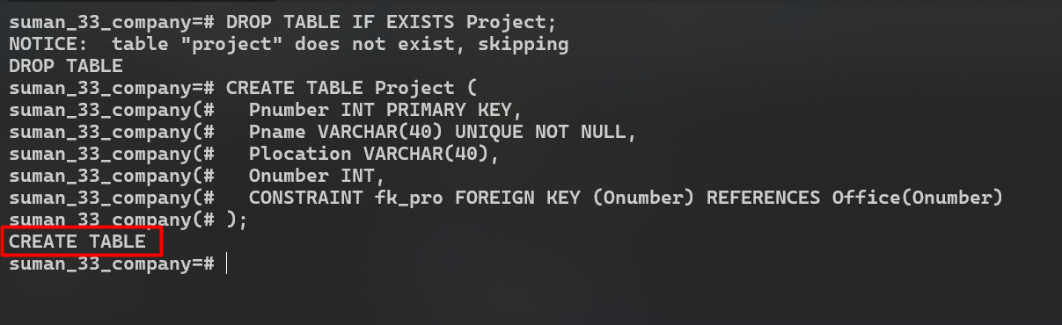**Output:**

**1d:** Works_on( ESSN, Pno); where ESSN references Employee SSN and Pno references to Pnumber from Project . Set cascade on update and cascade on delete to both.

**SQL Script:**

**DROP** **TABLE** **IF** **EXISTS** Works_on;

**CREATE** **TABLE** Works_on (

ESSN **INT**,

Pno **INT**,

**PRIMARY** **KEY** (ESSN, Pno),

**FOREIGN** **KEY** (ESSN) **REFERENCES** Employee(SSN) **ON** **UPDATE** **CASCADE** **ON** **DELETE** **CASCADE**,

**FOREIGN** **KEY** (Pno) **REFERENCES** Project(Pnumber) **ON** **UPDATE** **CASCADE** **ON** **DELETE** **CASCADE**

);

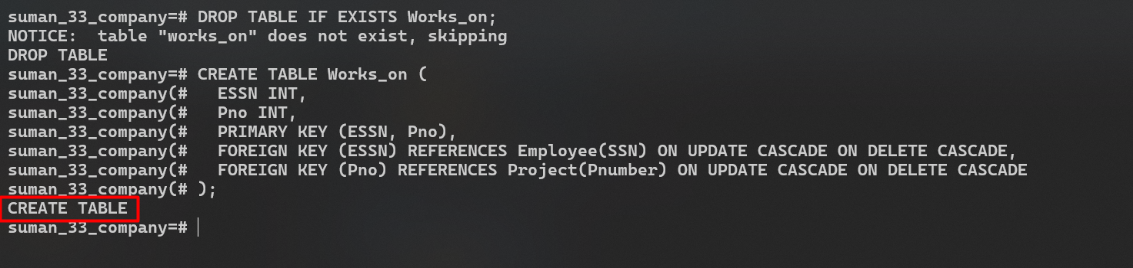**Output:**

**1e:** Dependents(Did, Dname, Dage, SSN); where SSN is Foreign key referencing the employee. Set NULL on delete and on update to the foreign key. Add constraint age_constraint using CHECK(Dage<16).

**SQL Script:**

**DROP** **TABLE** **IF** **EXISTS** Dependent;

**CREATE** **TABLE** Dependent (

Did **INT** **PRIMARY** **KEY**,

Dname **VARCHAR**(100),

Dage **INT**,

**CONSTRAINT** age_constraint **CHECK** (Dage < 16),

SSN **INT**,

**FOREIGN** **KEY** (SSN) **REFERENCES** Employee(SSN) **ON** **UPDATE** **SET** **NULL** **ON** **DELETE** **SET** **NULL**

);

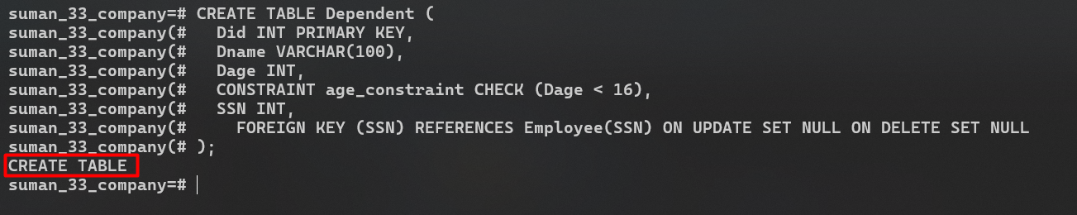**Output:**

**Outputs After Tables Creation.**

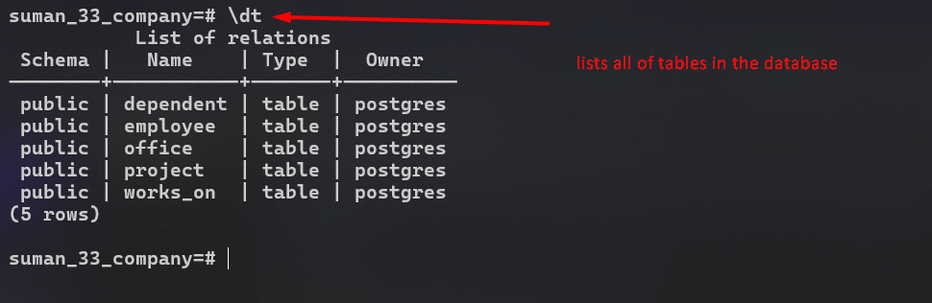

**Q2:** Alter table Dependent and add an attribute Drelation of type Char(50.

**SQL Script:**

**ALTER** **TABLE** dependent **ADD** **COLUMN** drelation **CHAR**(50);

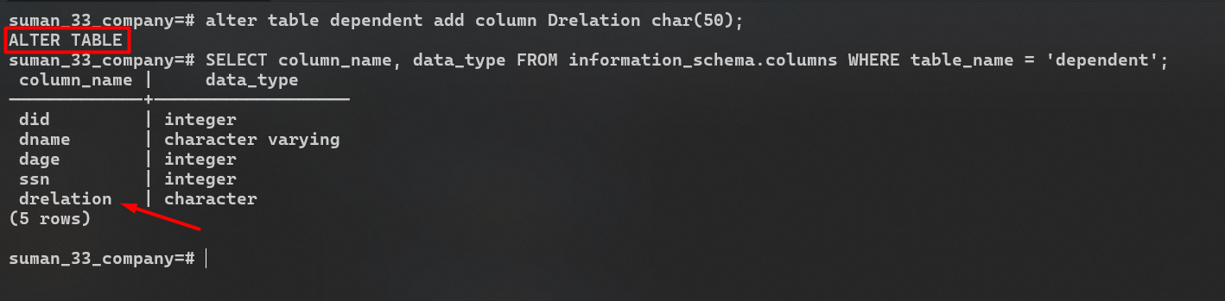**Output:**

**Q3:** Alter table Dependent and modify the attribute Drelation of type Char(50) to Varchar(50)

**SQL Script:**

**ALTER** **TABLE** dependent **ALTER** **COLUMN** drelation **TYPE** **varchar**(50);

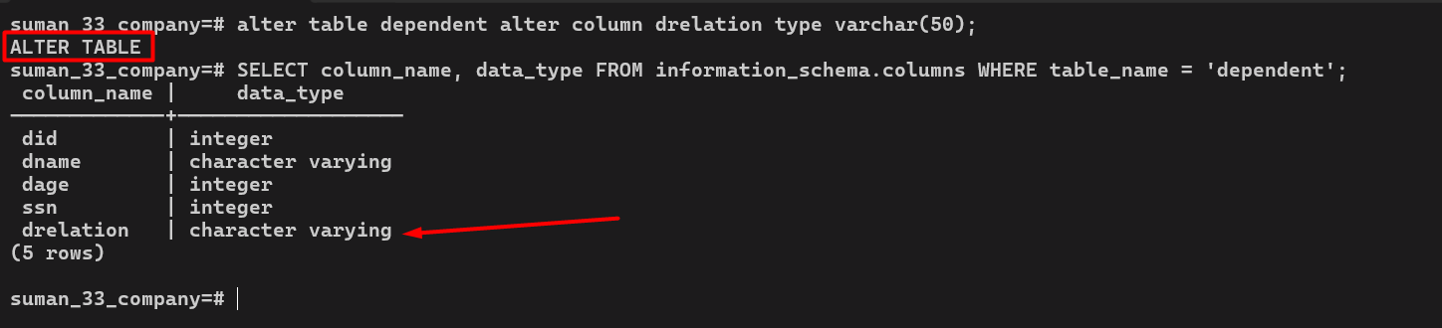**Output:**

**Q4:** Insert at least five tuples into the tables. (Illustrate insertion of single tuple and multiple tuples both). During insertion insert following as well.

There should be one record in the Employee table having Ename “Your name” i. e. Deric and SSN “Your roll number” e.g. 6.

There should be one record in the Project table having Pname =“Your name_ProjMDS” and Pnumber = 2*Your Roll number.

One of the tuple in Office table should have office name “Yourname_Office_Roll” i.e. Deric_Office_06. Similarly one of the tuple in employee should have salary 30000.

In addition, there should be one tuple in office table having office name Yourname_Ncell_Roll.

In the dependents table insert the rows with Dname and Drelation having values from your family. For example, Deric has his elder brother and mother as his dependents. So the table will have records with values Dname=Denish and Drelation=Brother and Dname=Gayatri and Drelation=Mother. Take assumptions based on your family members while inserting the values.

**For Office Table**

**Before Insertion:**

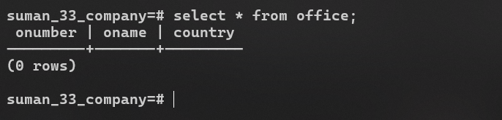

**Single Insertion SQL Script:**

**INSERT** **INTO** ***Office*** (***Onumber***, ***Oname***, ***Country***) **VALUES** (1, **'Suman_Office_33'**, **'Nepal'**);

**Output:**

**Multiple Insertion SQL Script:**

**INSERT** **INTO** ***Office*** (***Onumber***, ***Oname***, ***Country***)

**VALUES**

(2, **'Suman_Ncell_33'**, **'Nepal'**),

(3, **'Prabhat Ale'**, **'USA'**),

(4, **'Anish Thapaliya'**, **'India'**),

(5, **'Gaurav Pandey'**, **'Japan'**);

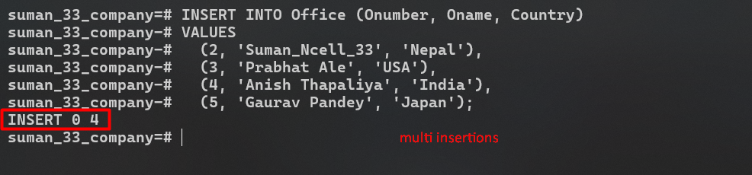**Output:**

**After Insertion into Office Table.**

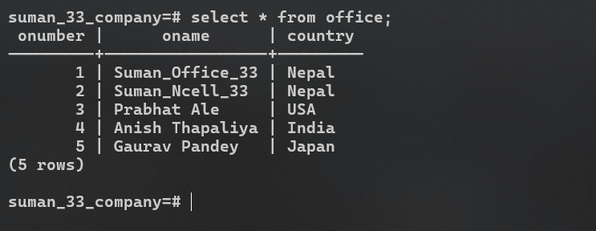

**For Employee Table**

**Before Insertion:**

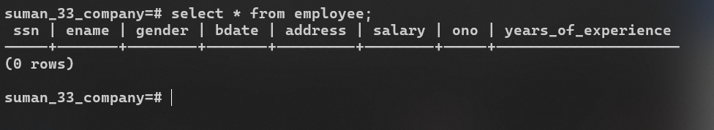

**Single Insertion SQL Script:**

-- for employee table

**INSERT** **INTO** ***employee*** (***SSN***, ***Ename***, ***Gender***, ***Bdate***, ***Address***, ***SALARY***, ***Ono***, ***Years_of_experience***)

**VALUES** (33, **'Suman Paudel'**, **'M'**, **'1997-10-22'**, **'Kathmanu, Nepal'**, 30000.00, 1, 3);

**Output:**

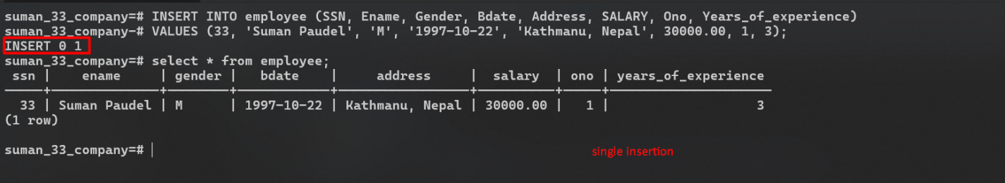

**Multi Insertion SQL Script:**

**INSERT** **INTO** ***employee*** (***SSN***, ***Ename***, ***Gender***, ***Bdate***, ***Address***, ***SALARY***, ***Ono***, ***Years_of_experience***)

**VALUES**

(1, **'Rekha Thapa'**, **'F'**, **'1992-03-22'**, **'Kathmandu, Nepal'**, 55000.00, 2, 5),

(2, **'KP Oli'**, **'M'**, **'1978-11-08'**, **'Bhaktapur, Nepal'**, 72000.00, 3, 12),

(3, **'Puspa Kamal Dahal Pracanda'**, **'M'**, **'1990-09-01'**, **'Lalitpur, Nepal'**, 48000.00, 4, 3),

(4, **'Rabi Lamichane'**, **'M'**, **'1983-04-30'**, **'Chitwan, Nepal'**, 60000.00, 4, 7);

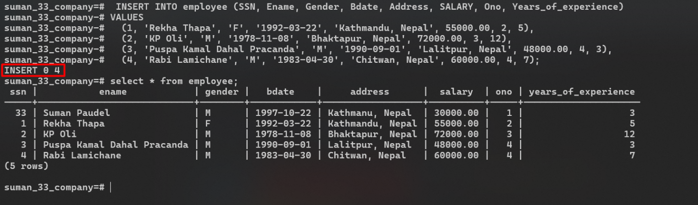**Output:**

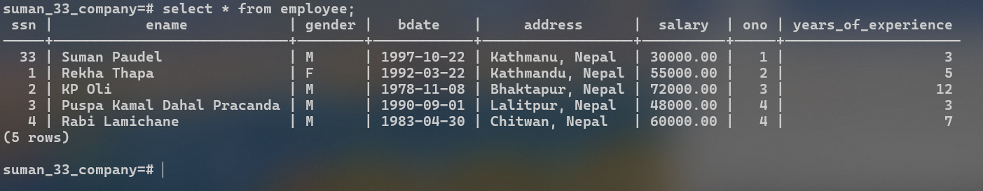**After Insertion into Employee Table.**

**For Project Table**

**Before Insertion:**

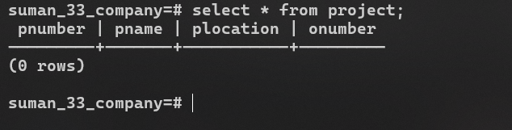

**Single Insertion SQL Script:**

**INSERT** **INTO** ***Project*** (***Pnumber***, ***Pname***, ***Plocation***, ***Onumber***)

**VALUES** (66, **'Suman_ProjMDS'**, **'Kathmandu'**, 1);

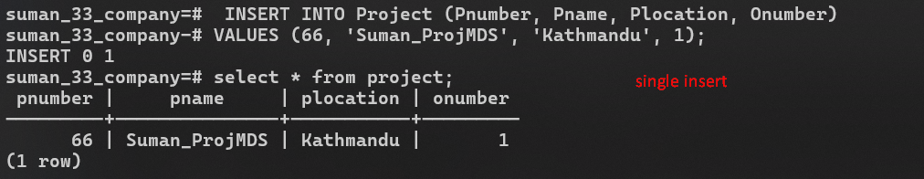**Output:**

**Multiple Insertion SQL Script:**

**INSERT** **INTO** ***Project*** (***Pnumber***, ***Pname***, ***Plocation***, ***Onumber***)

**VALUES**

(2, **'Project Kathmandu'**, **'Kathmandu'**, 2),

(3, **'Project Butwal'**, **'Butwal'**, 3),

(4, **'Project Chitwan'**, **'Chitwan'**, 4),

(5, **'Project Dhangadi'**, **'Dhangadi'**, 5);

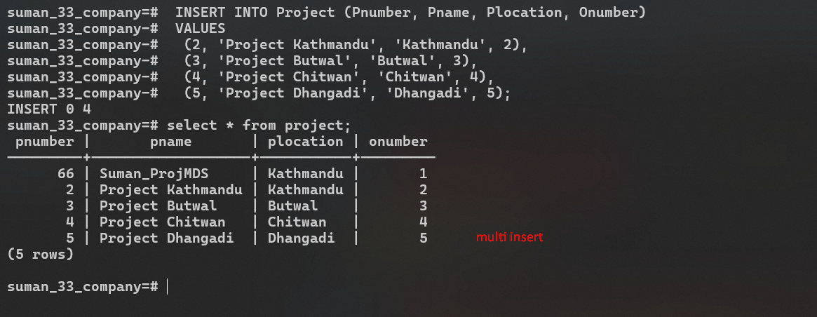**Output:**

**After Insertion into Project Table.**

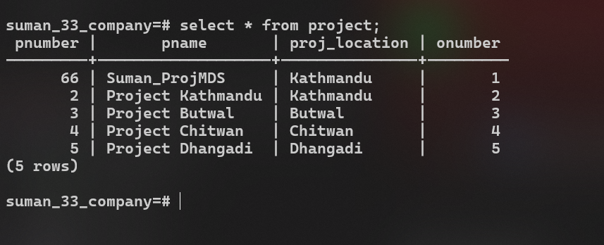

**For Works_on Table**

**Before Insertion:**

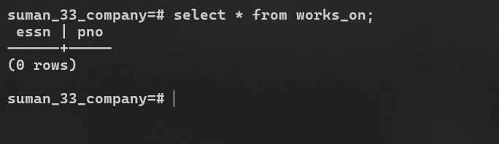

**Single Insertion SQL Script:**

-- for employee table

**INSERT** **INTO** ***Works_on*** (***ESSN***, ***Pno***)

**VALUES** (33, 66);

**Output:**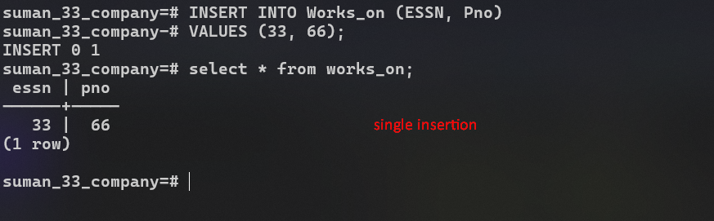

**Multiple Insertion SQL Script:**

**INSERT** **INTO** ***Works_on*** (***ESSN***, ***Pno***)

**VALUES**

(1, 2),

(2, 3),

(3, 4),

(4, 5);

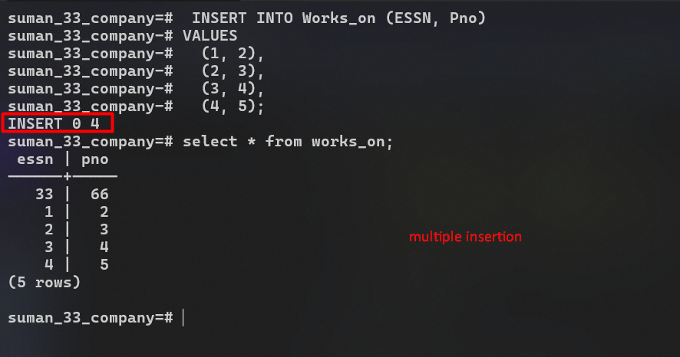**Output:**

**After Insertion into Works_on Table.**

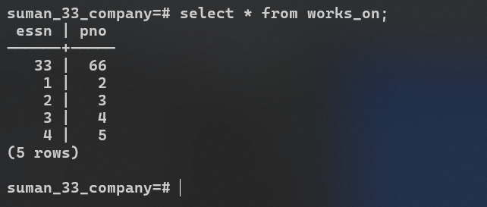

**For Dependent Table**

**Before Insertion:**

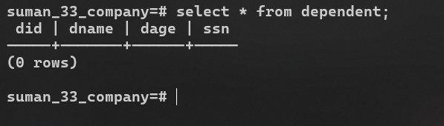

**Single Insertion SQL Script:**

-- for employee table

**INSERT** **INTO** ***Dependent*** (***Did***, ***Dname***, ***Dage***, ***SSN***, ***Drelation***)

**VALUES** (1, **'Pushpa Panta Jaisi'**, 13, 33, **'Mother'**);

**Output:**

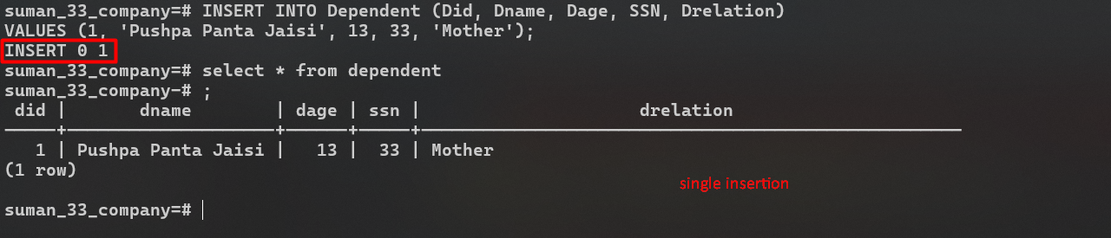

**Multiple Insertion SQL Script:**

**INSERT** **INTO** ***Dependent*** (***Did***, ***Dname***, ***Dage***, ***SSN***, ***Drelation***)

**VALUES** (2, **'Krishna Prasad Jaishi'**, 13, 33, **'Father'**),

(3, **'Silu Poudel'**, 12, 33, **'Sister'**),

(4, **'Sujita Sharma'**, 9, 33, **'Cousin Sister'**),

(5, **'Prabin Adhikari'**, 14, 33, **'Cousin Brother'**);

**Output:**

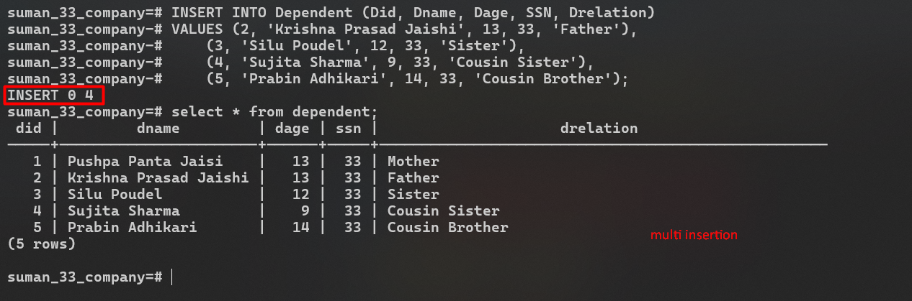

**After Insertion into Dependent Table.**

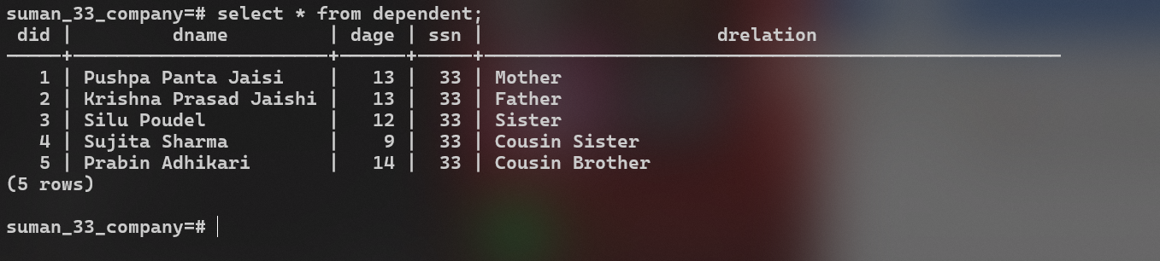

**5.** Update the name of office having office name “Yourname_Ncell_Roll” to “Yourname_Ntc_Roll”.

**SQL Script:**

**UPDATE** ***office*** **SET** ***oname*** = **'Suman_NTC_33'** **WHERE** ***oname*** = **'Suman_Ncell_33'**;

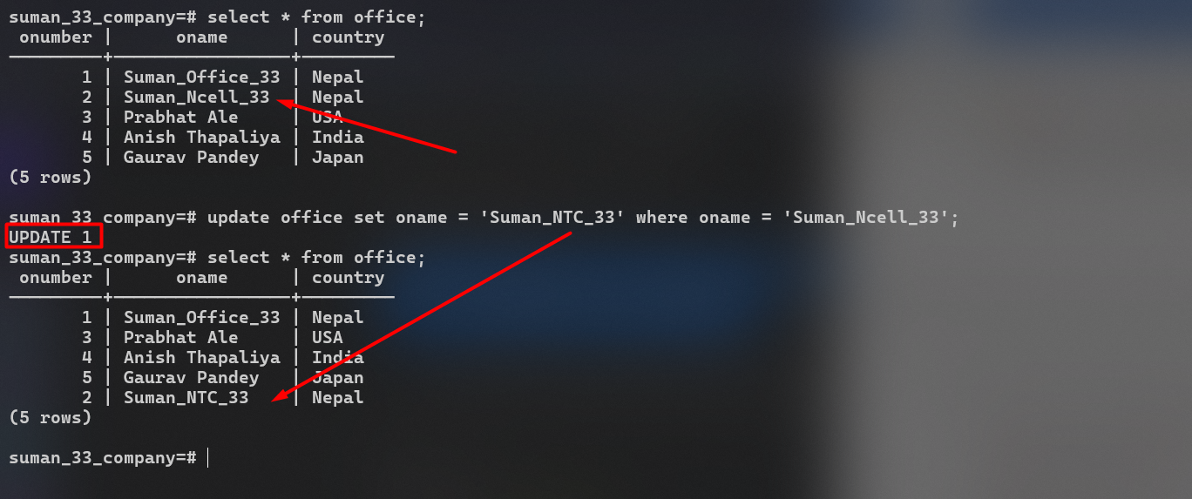**Output:**

**6.** Delete those employees whose SSN is 1.

**SQL Script:**

**DELETE** **FROM** ***employee*** **WHERE** ***ssn*** = 1;

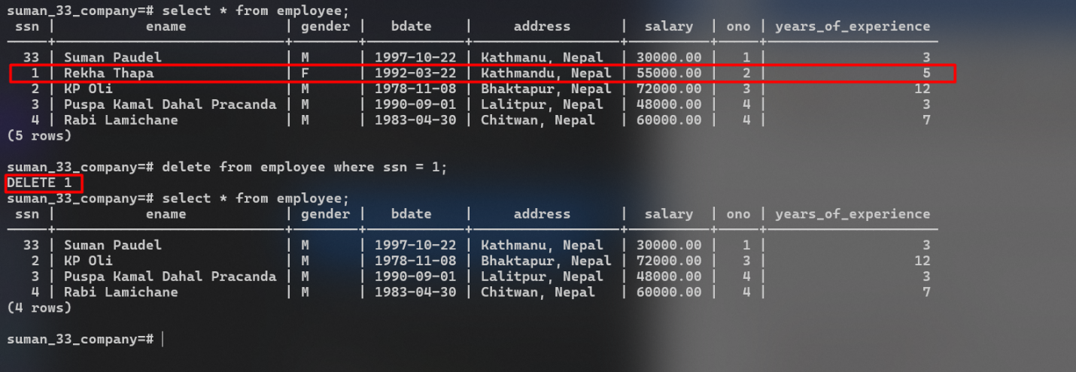**Output**

**7.** Alter table Project to rename the attribute in Plcoation to Proj_location

**SQL Script:**

**ALTER** **TABLE** project **RENAME** plocation **to** Proj_location;

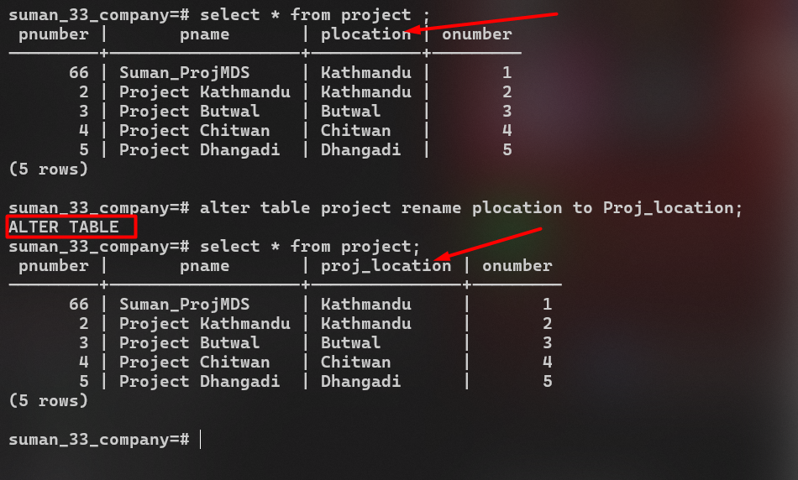**Output:**

**8.** Select tuples from all of the tables individually.

**Employee Table**

**SQL Script:**

**SELECT** * **FROM** ***employee***;

**Output:**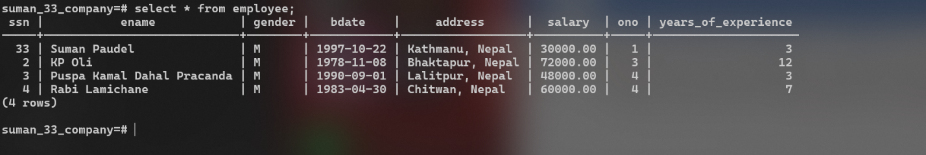

**Office Table**

**SQL Script:**

**SELECT** * **FROM** ***office***;

**Output:**



**Project Table**

**SQL Script:**

**SELECT** * **FROM** ***project***;

**Output:**



**Works_on Table**

**SQL Script:**

**SELECT** * **FROM** ***workson***;

**Output:**



**Dependents Table**

**SQL Script:**

**SELECT** * **FROM** ***dependents***;

**Output:**



**All Tables at once.**

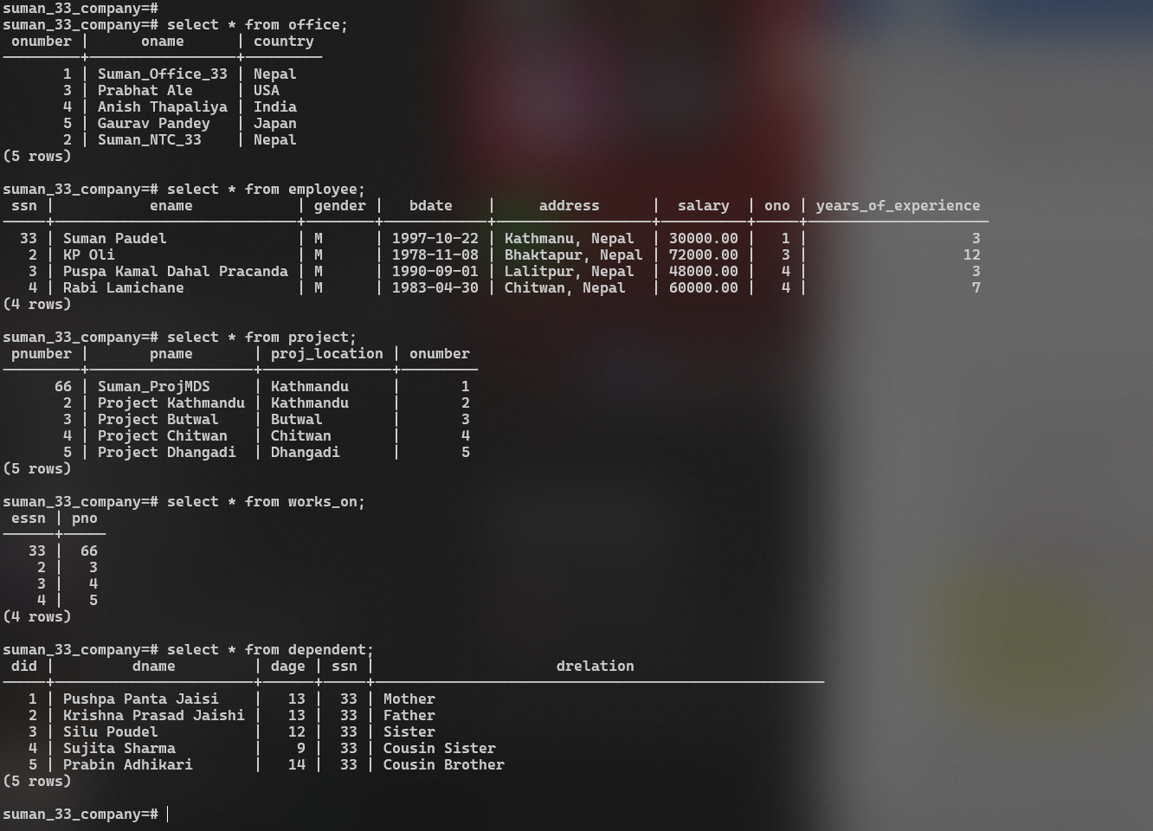

**9.** Drop the table Works_on. Make sure to export your database before you drop it so that you can recover.

**Exported the database before dropping tables and database.**



**SQL Script**

**DROP** **TABLE** works_on;

**Output:**

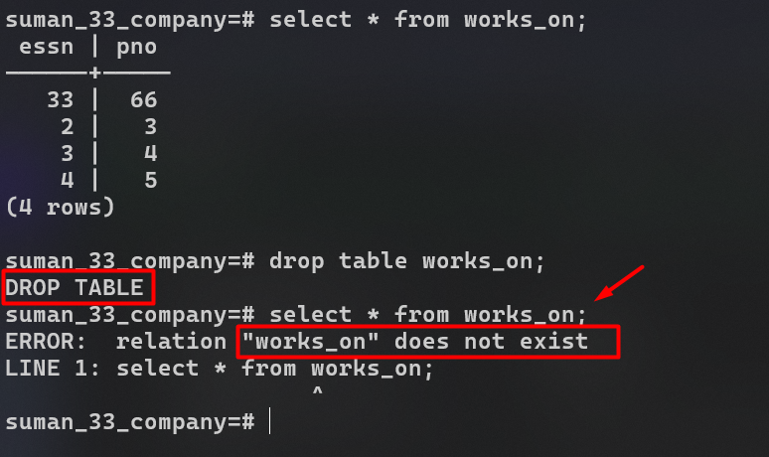

**10.** Drop the constraint age_constraint from dependent table

**SQL Script:**

**ALTER** **TABLE** dependent **DROP** **CONSTRAINT** age_constraint;

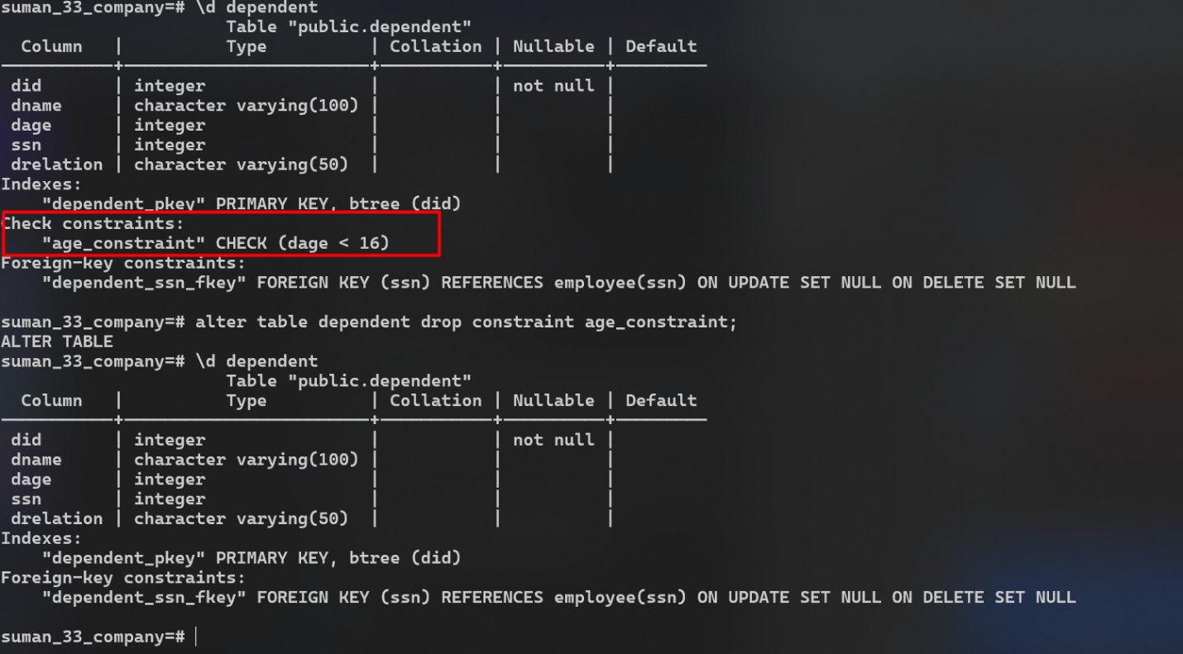**Output:**

**11.** Drop the database COMPANY. Make sure to export your database before you drop it so that you can recover.

**SQL Script:**

**DROP** **DATABASE** suman_33_company;

**Output:**

